**ASSIGNMENT- 1**

|  |  |
| --- | --- |
| **PROJECT NAME** | **CUSTOMER CARE REGISTRY** |
| **NAME** | **S.NIVEDHA** |
| **ROLL NO** | **4211191031035** |
| **TEAM ID** | **PNT2022TMID10765** |

1. **PROGRAM**

<!DOCTYPE html>

<html>

<head>

<title>Table</title>

<link rel="stylesheet" href="table.css">

</head>

<body>

<center>

<table border="4">

<thead>

<tr>

<th>First Name</th>

<td><input type="text" name="fname" id="fname"></td>

</tr>

</thead>

<tbody>

<tr>

<th>Last Name</th>

<td><input type="text" name="lname" id="lname"></td>

</tr>

<tr>

<th>Gender</th>

<td><input type="radio" name="gender" id="gender" value="None">None

<input type="radio" name="gender" id="gender" value="Male">Male

<input type="radio" name="gender" id="gender" value="Female">Female

<input type="radio" name="gender" id="gender" value="Others">Others</td>

</tr>

<tr>

<th>Department</th>

<td><select name="DEPT" id="dept">

<option value="NONE">NONE</option>

<option value="CSE">CSE</option>

<option value="IT">IT</option>

<option value="ECE">ECE</option>

<option value="EEE">EEE</option>

<option value="CIVIL">CIVIL</option>

<option value="MECHANICAL">MECHANICAL</option>

</select></td>

</tr>

<tr>

<th>Email</th>

<td><input type="email" name="email" id="email"></td>

</tr>

<tr>

<th>Password</th>

<td><input type="password" name="password" id="password"></td>

</tr>

<tr>

<th>Age</th>

<td><input type="text" name="age" id="age"></td>

</tr>

<tr>

<th>Address</th>

<td><textarea id="address"></textarea></td>

</tr>

<tr id="btna">

<td colspan="2"><input type="button" name="button" id="btn" value="Add" onclick="AddRow()"></td>

</tr>

<tr>

<td ><a copage.html" target="_default"><button >SUBMIT</button>

</td>

</tr>

</tbody>

</table>

<table border="4" id="show">

<thead>

<tr>

<th>First Name</th>

<th>Last Name</th>

<th>Gender</th>

<th>Department</th>

<th>Email</th>

<th>Password</th>

<th>Age</th>

<th>Address</th>

</tr>

</thead>

</table>

</center>

<script>

var list1 = [];

var list2 = [];

var list3 = [];

var list4 = [];

var list5 = [];

var list6 = [];

var list7 = [];

var list8 = [];

var n = 1;

var x = 0;

function AddRow(){

var AddRown = document.getElementById('show');

var NewRow = AddRown.insertRow(n);

list1[x] = document.getElementById("fname").value;

list2[x] = document.getElementById("lname").value;

list3[x] = document.getElementById("gender").value;

list4[x] = document.getElementById("dept").value

list5[x] = document.getElementById("email").value;

list6[x] = document.getElementById("password").value;

list7[x] = document.getElementById("age").value;

list8[x] = document.getElementById("address").value;

var cel1 = NewRow.insertCell(0);

var cel2 = NewRow.insertCell(1);

var cel3 = NewRow.insertCell(2);

var cel4 = NewRow.insertCell(3);

var cel5 = NewRow.insertCell(4);

var cel6 = NewRow.insertCell(5);

var cel7 = NewRow.insertCell(6);

var cel8 = NewRow.insertCell(7);

cel1.innerHTML = list1[x];

cel2.innerHTML = list2[x];

cel3.innerHTML = list3[x];

cel4.innerHTML = list4[x];

cel5.innerHTML = list5[x];

cel6.innerHTML = list6[x];

cel7.innerHTML = list7[x];

cel8.innerHTML = list8[x];

n++;

x++;

}

</script>

</body>

</html>

**OUTPUT:**

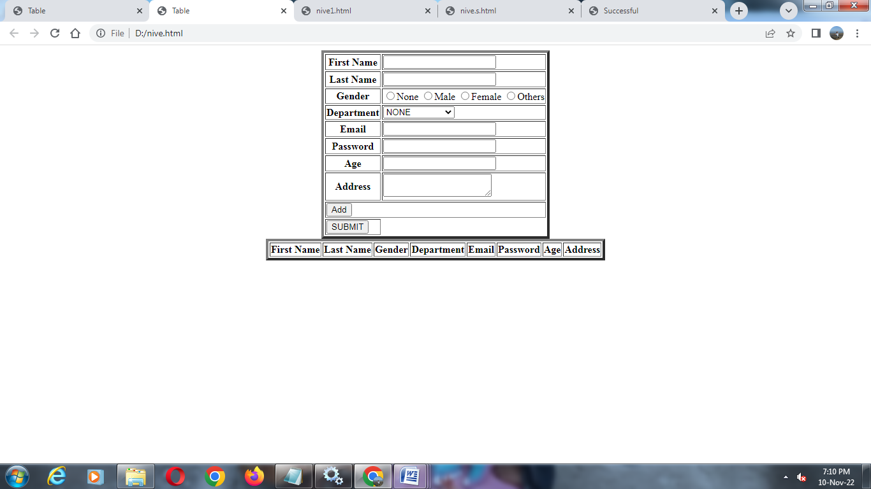

1. **PROGRAM:**

|  |
| --- |
| <!DOCTYPE html> |
|  | <html> |
|  | <head> |
|  | <title>Successful</title> |
|  | </head> |
|  | <body style="background-color:green;"> |
|  | <h1 align="center"><b>Your Data Has Been Stored And Registered Successfully!!</b></h1> |
|  | </body> |
|  | </html> |

**OUTPUT:**

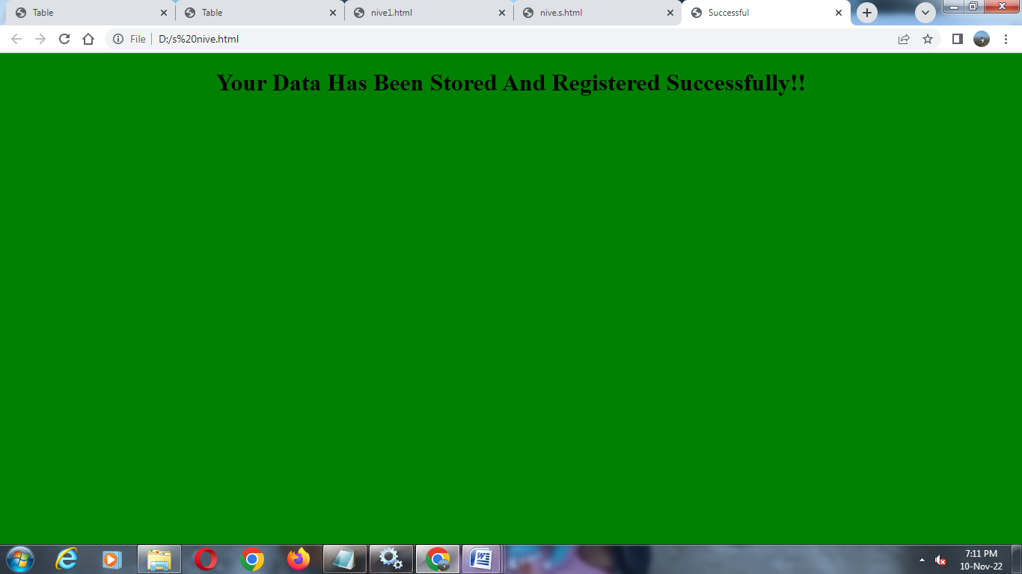

**3. PROGRAM:**

|  |
| --- |
| table{ |
|  | margin-top: 50px; |
|  | text-align: center; |
|  | background: #800080; |
|  | color: #FF0000; |
|  | } |
|  |  |
|  | #show th, #show td{ |
|  | padding: 12px; |
|  | } |
|  |  |
|  | #btna td input{ |
|  | width: 100%; |
|  | } |